1a. LINEAR REGRESSION (UNIVARIATE) ON SKLEARN-MAKE REGRESSION DATASET

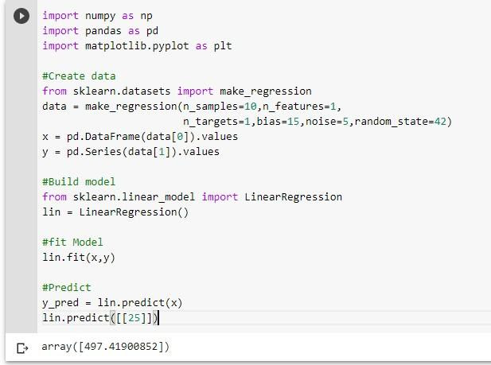

1b. LINEAR REGRESSION (MULTIVARIATE) ON SKLEARN-MAKE REGRESSION DATASET

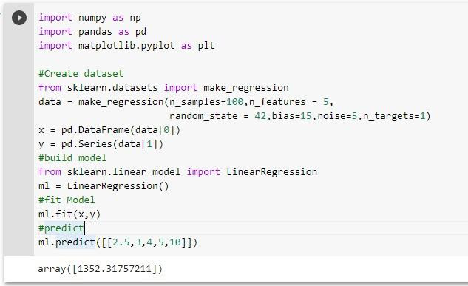

1c.POLYNOMIAL REGRESSION ON SKLEARN-MAKE REGRESSION DATASET

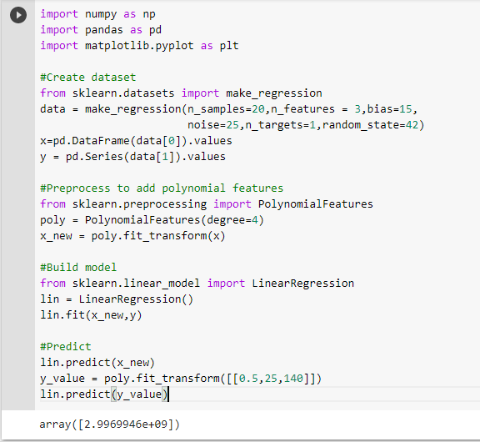

1d. LASSO REGRESSION ON SKLEARN-MAKE REGRESSION DATASET

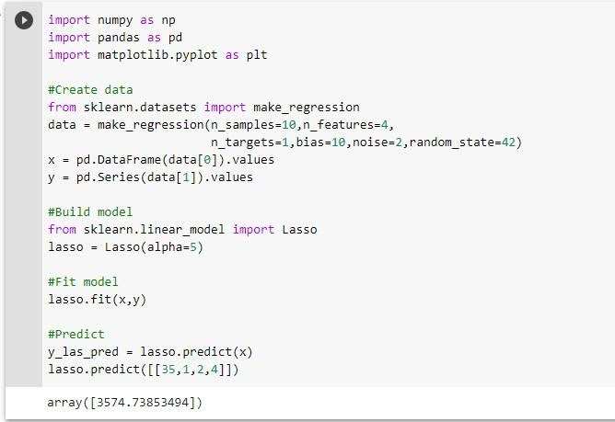

1e. RIDGE REGRESSION ON SKLEARN-MAKE REGRESSION DATASET

